WKMHA Initiation Program Information 2019/2020
Welcome to West Kelowna Minor Hockey!
Here is some information about what you can expect this season
The Office is located at the Mount Boucherie Arena Complex inside the Jim Lind Arena next to the visitor’s bench. The office hours are Tuesday and Thursday 930am-430pm. Outside of office hours you can email westkelownaminorhockey@shaw.ca for assistance or refer to the information on our website www. westkelownaminorhockey.com
West Kelowna Minor Hockey is run by an elected Board of Directors. Directors are volunteer positions who serve 2 year alternating terms. Elections take place at the Annual General Meeting each May. The complete list of these Executive members and their duties can be found on our website
Support Staff: The Head Coach, Administrator, Tournament Coordinator, Equipment Manager and Goalie Equipment Manager
WKMHA Divisions
Initiation 5&6 year olds
Novice 7&8 year olds
Atom 9&10 year olds
Peewee 11&12 year olds
Bantam 13&14 year olds
Midget 15, 16&17 year olds
There is no tiering in the Initiation or Novice Divisions
In the Atom Division, players can try out for Atom Development teams (Atom Dev A or Atom Dev C) or play recreation hockey
In the Peewee –Midget Divisions, Players can try out for Rep (Tier 2 or Tier 3) or play recreation hockey
Registration and Other Fees
Your registration fees covers your child’s ice times, referees, home tournament participation, insurance and Memory Mate photo.
Once teams are formed, the Head Coach and Manager will hold a meeting to discuss any additional expenses for the season. This may include tournament fees ($500-$900 per team, per tournament), year-end party, coach/staff thank you gifts, t-shirts, name bars etc. Your team may opt to do fundraising to offset some of these costs. All fundraisers must be approved by the WKMHA board.
As part of registration all players receive a “Tim Horton’s” sponsored jersey and socks to keep
Financial Assistance is available through Jumpstart, Kidsport or Lace ‘Em Up. Links are at the bottom of our registration page
Required Equipment
All players are required to wear the following:
*athletic support- jock or jill *Helmet and full face mask or visor
*shin pads *skates
*shoulder pads *jersey
*neck guard *socks
*elbow pads *hockey pants
*gloves * hockey stick
*hockey gear bag * stick tape

Jersey’s and hockey socks will be provided by the Association once teams are formed. Please bring a practice jersey and socks to evaluations
It is also recommended that players have under shirt/pants to wear under equipment, a water bottle and mouth guard
WKMHA provides goalie equipment for each team to use for the season. Additional sets may be available upon request to Scott Dawson at hockeyrepairs@yahoo.ca
All goalie equipment and team pucks, cones, pinnies, etc are to be returned to WKMHA at the end of the season

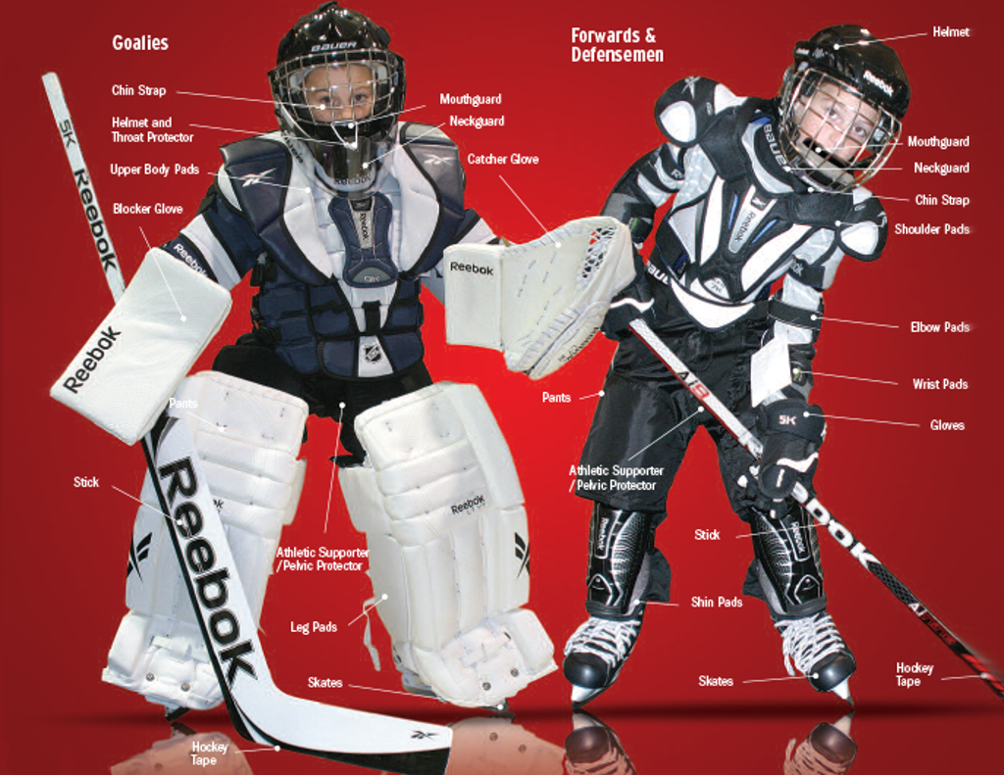
Schedule
There is no set schedule for the ANY division. The association books ice Monday through Friday from 300pm-700pm for the Initiation and Novice Divisions. WKMHA weekend times are Saturday between 11am and 200pm and Sundays from noon to 300pm. Games at other associations can be booked at any time pending their ice availability.
Schedules are not determined until coaches are in place for availability reasons.
We do not take requests for players to play on certain days of the week
Code of Conduct
One parent from each family is required to take “Respect in Sport for Parents” as part of your child’s registration package. The link for this course is forwarded to you during the registration process. There is a nominal fee to take this course
Parents are also asked to sign and return a code of conduct at the time of registration

Zero Tolerance Policy
Verbal abuse of Officials, players, coaches and volunteers of WKMHA will not be tolerated. Under no circumstances may a Coach, Assistant Coach, Manager, Safety Person or Parent verbally attack a referee, linesman, player or volunteer of the association. This will result in immediate suspension, pending a discipline meeting.

Should a member of WKMHA be removed, or banned from our facilities by the District of West Kelowna, this would also include all parks, buildings etc maintained by the District of West Kelowna under the district by-laws.

Zero Tolerance also includes the use of illegal drugs and alcohol by players within any WKMHA function. As well, WKMHA has a zero tolerance policy for alcohol and tobacco use on any bus being used to transport teams to any WKMHA functions. It is the responsibility of the coaches and/or managers to enforce the rules within the players and all team staff. Suspensions will occur.

Fair Play Policy
WKMHA PHILOSOPHY

Fair Play Program (Respect, Integrity and Fairness)
- Fair play is in place to ensure that each player gets equal participation in game situations at the Novice, Recreational and Development levels.
- Ice time lost due to disciplinary action, injuries, and suspensions does not apply.
- To foster and enhance mutual respect, understanding and the principles of good sportsmanship and Fair Play amongst everyone.
- Promote safety, respect, enjoyment and good competition.
- WMHA Fair Play philosophy extends to the full adoption of the Player, Parent, and Coaching Contract (see Appendix).

Fair Play Program Tips for Parents
- The main expectation of the Fair Play Program requires parents to provide for their sons/daughters positive role models. Yelling negative comments at opposing players, coaches or officials will not be tolerated.
- If you are in the stands and the person next to you is being negative, tell that individual that he/she is not only embarrassing his/her son/daughter, but the embarrassment is spread to the team and all other participants’ on/off the ice.
- Accept the fact that mistakes will be made by some individuals during any game. Coaches, athletes and officials make mistakes. Be tolerant of mistakes, you are watching AMATEUR SPORTS.
- If you cannot accept what you perceive, volunteer in the Association and participate in order to correct what you consider to be wrong. Yelling and screaming negatives will only accomplish to isolate you and your child from your friends and from your child.
- The Fair Play Program expects parents to understand that all the players want to have fun playing the game of hockey. Parents should encourage this fun in a positive way.
- The Fair Play Program encourages parents to maintain a positive outlook towards not only their son/daughter, but to all the teammates and to the opposing players as well. Parents feel good when opposing fans clap for their players and their team. Share that good feeling by clapping for the opposing player or team when a good play occurs.
- The Fair Play Program expects parents to understand that you are watching young players having fun enjoying a sport they love. The young players are NOT there to entertain the parents in the stands.
- The children you watch on the ice do hear and see you at the rinks. The children look to you for acceptance and praise.
- The Fair Play Program expects that positive praise for your child and others should not be lacking. You as a parent are a vital part of the game.

The Fair Play program encourages your participation in your son/daughter’s hockey experiences.
  - Respect the Rules.
  - Respect the Officials and their decisions.
  - Respect the opponents.
  - Maintain your self-control at all times.

24 Hour Rule
When an issue occurs and a party has a resulting complaint to make or an issue to be resolved, they are asked to wait 24 hours.
Coaches should not discuss any try-out related situations, game, a game incident or a situation that occurred during the game that has provoked an adverse emotional response or created a hostile situation until at least 24 hours after the fact. A Member is not to approach a coach to discuss a try-out related situation, a game, a game incident or a situation that occurred during the game that has provoked an adverse emotional response or a hostile situation until at least 24 hours after the fact.
For parents, it is important to separate game emotions from the best interests of their child’s sports development. The intent of this rule is to move an emotional and confrontational discussion away from the presence of the players, and to allow the parties to “cool off”, compose themselves and put the provoking incident or situation that occurred in the game in perspective before meeting to discuss it.
Conflict within a team: Parent>Coach>Division Manager>Director of Divisions
Conflict regarding the Coach: Parent>Division Manager>Director of Coaches
Conflict regarding the Division Manager: Parent>Director of Divisions

Initiation Division
The success of grassroots hockey programming is measured by the level of development young players achieve. To optimize these levels, dedicated adults must play a large role as leaders and teachers who will create a challenging and motivating environment for all young players.
The goals and objectives of Initiation hockey programming are to:
- Teach all basic skills of hockey so players can enjoy the game.
- Assist in development and enhancement of physical literacy and basic motor patterns.
- Develop and encourage the concepts of being a team member through player participation in both on-ice and off-ice activities.
- Encourage aspects of fitness, fair play and cooperation while having fun.
The details of Initiation hockey:
- Approximate Start date: Sept 14th, last day- March 12th, Winter Break Dec 21st to Jan 5th
- # of ice times per week: 2 or 3
- Evaluations: will take place for the purpose of creating balanced teams
- Ice times: Ultimate Hockey Centre 1322 Stevens Rd
Jim Lind and Royal LePage Place 2760 Cameron Rd
- Game structure: Full ice at UHC on modified surface, Cross ice format on full size rink surfaces. See Cross ice info below
- Team: Recommended 13 -15 players on a team, subject to primary facility used & registration #’s.
- League: Scoreboard not used and no league standings.
- Travel: Restricted to between South Okanagan and Salmon Arm.
- Tournaments: Maximum number of tournaments per team is 2 plus home WKMHA tournament.
- Games: To follow Pond Hockey rules with buzzer at 2-minute shifts.
- Each team requires a coach, assistant coaches, safety person, on ice helpers and a manager
- Initiation Division Manager will assign all games during the season
- Home tournament: December 28 & 29, 2019 at Jim Lind
Cross ice info
At times, there can be concerns from parents about how small-area games may impact their child’s hockey development. But we ask parents to trust the development experts and not worry about their child being the best player on the ice. It is also important to remind parents that putting young players into a competitive environment too early will compromise their development. Children need to be placed into competitive situations that suit their age-appropriate abilities. And parents need to be realistic about what children should be able to do all age levels. This is why Hockey Canada’s Long-Term Player Development strategy is so important.
It is important to fully understand and appreciate the benefits of cross-ice and half-ice hockey. The configuration of dividing the playing surface into cross-ice or half-ice is a decision that has been made in consultation with experts in athlete development. An overview of very simple statistics illustrates a number of advantages to the smaller surface games model
- Increases the emphasis on skating skills, including elements like agility, balance, coordination and quickness.
- Number of puck battles increases.
- Puck control and puck protection skills are enhanced, which will help players succeed at higher levels.
- Fundamentals of skating, puck control, passing and shooting are reinforced at a greater rate.
- Increase in incidental body contact requires players to play with their head up, preparing players for proper use of body contact and checking skills in the future.
- Less time and space increase the frequency of making hockey decisions.
- Better environment for teaching ice awareness and boosts hockey sense
- Over time, the intensity level of competition increases with the progressive skill development of players.
For more information on Cross ice programming go to
https://www.hockeycanada.ca/en-ca/hockey-programs/coaching/initiation/mha/policy
Team Roles and Responsibilities and Certification Requirements
Volunteers are required for the following positions for each team:
- Head Coach
Promote player development using the Hockey Canada Initiation Program guidelines
Encourage and foster sportsmanship and teamwork
On ice during practices and games
- Assistant Coach
Promote player development using the Hockey Canada Initiation Program guidelines
Encourage and foster sportsmanship and teamwork
On ice during practices and games
- Safety Person
First aid for players and bench staff
Ensure ice surface is safe
Ensure players wear appropriate protective equipment
General Safety awareness
Responsible for injury reporting
Responsible for “return to play” process
- Team Manager
Works with coaches to organize details of the season
Communicate season details to team members/parents
Collect team fees
- On Ice Helpers
Assist the Coach and assistant coaches during practice times
NOT to be on the bench or ice during games as they do not require the same certification
All volunteer positions (coach, assistant coach, safety person, on ice helper, manager) require certification
For volunteer certification requirements, refer to the “Coaches” page on our website
http://www.westkelownaminorhockey.com/content/coach-info
The cost of course fees will be reimbursed by WKMHA once bench staff and on ice helpers are assigned to teams. Please submit receipts to westkelownminorhockey@shaw.ca

Team Pictures
Team pictures are usually scheduled in early November- TBA. Please have your player fully dressed for picture day and be prepared 15 minutes prior to your scheduled picture time. Each player will receive a team photo and an individual picture as part of their registration. Additional photos may be purchased. Each player requires a completed order form to be submitted whether additional photos are ordered or not. Team managers will supply the order forms

